Image Sharpening Using Unsharp Masking
Experiment No: 23
Aim
To perform sharpening of an image using the Unsharp Masking technique in Python using OpenCV.
Theory
Unsharp masking is an image sharpening technique in which a blurred version of the original image is subtracted from the original image to create an unsharp mask. The mask is then added back to the original image to produce a sharper image.
The basic equations are:
where:
- original image
- blurred imag
Tools Required
- Python 3.x
- OpenCV (cv2)
- NumPy
- VS Code / PyCharm / Jupyter Notebook
- Input image (image.jpg)
Procedure
- Install OpenCV and NumPy:
Bash
pip install opencv-python numpy
- Read the input image using OpenCV.
- Convert the image to grayscale.
- Create a blurred version of the image using Gaussian Blur.
- Subtract the blurred image from the original image to obtain the unsharp mask.
- Add the unsharp mask to the original image.
- Display the original, blurred, unsharp mask, and sharpened images.
Code
Python
Run
import cv2
import numpy as np

# Read the image
image = cv2.imread("image.jpg")

# Check if image is loaded
if image is None:
print("Error: Image not found!")
exit()

# Convert image to grayscale
gray = cv2.cvtColor(image, cv2.COLOR_BGR2GRAY)

# Create blurred image
blurred = cv2.GaussianBlur(gray, (5, 5), 0)

# Create unsharp mask
unsharp_mask = cv2.subtract(gray, blurred)

# Sharpen the image
sharpened = cv2.add(gray, unsharp_mask)

# Display images
cv2.imshow("Original Image", gray)
cv2.imshow("Blurred Image", blurred)
cv2.imshow("Unsharp Mask", unsharp_mask)
cv2.imshow("Sharpened Image", sharpened)

# Wait for key press
cv2.waitKey(0)

# Close windows
cv2.destroyAllWindows()
Output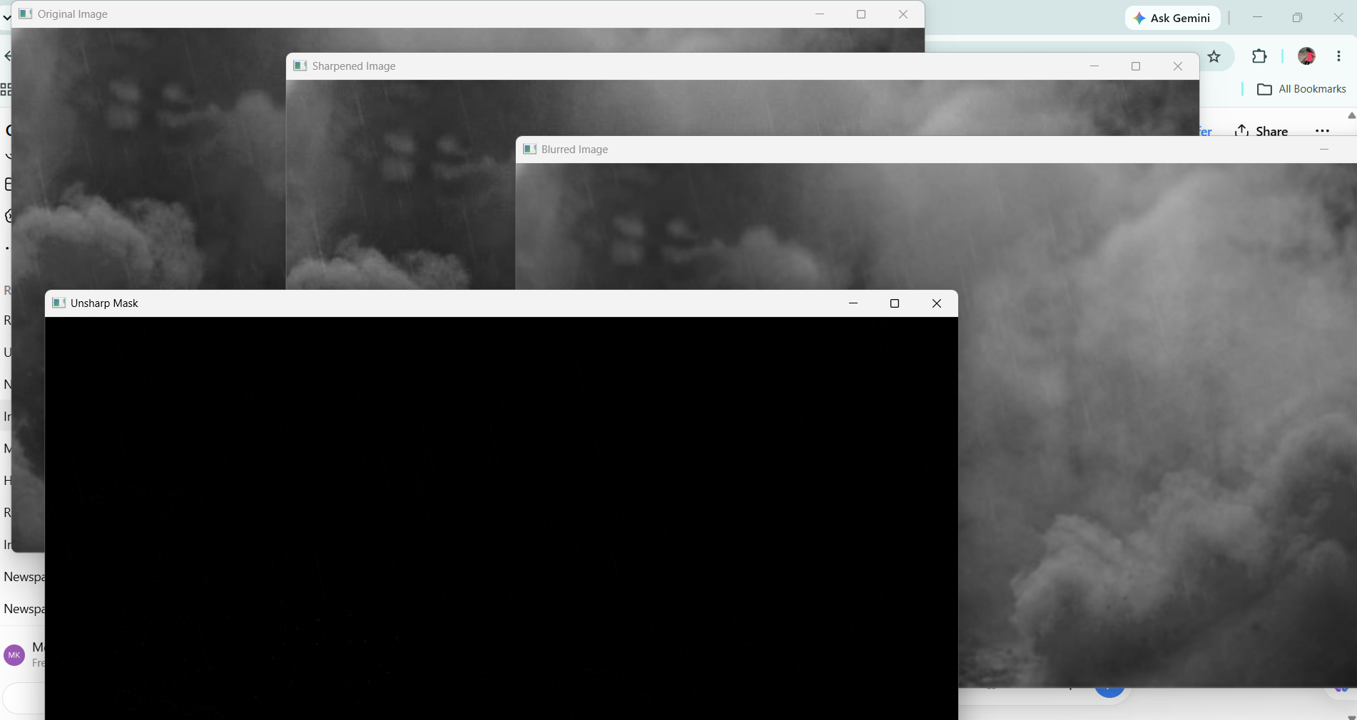
Result
The image was successfully sharpened using the Unsharp Masking technique. The blurred image was subtracted from the original image to create an unsharp mask, which was then added to the original image to produce a sharper image.

